Project Development Phase SPRINT-2

|  |  |
| --- | --- |
| Team ID | PNT2022TMID31937 |
| Project Name | Project – Retail Store Stock Inventory Analytics |

SPRINT-2:

Data Exploration

DATA EXPLORATION

* Download and Load the Dataset
* Sales by Year
* Price by Year
* Stock by Year
* Sales by M_Data colored by M_Data
* Stock by M_Data colored by M_Data
* Price by M_Data colored by M_Data
* Sales Sunburst
* Stock Summary
* Price Sunburst
* Year hierarchy colored by Year and sized by top 10 Sales
* Stock and Sales for M_Data colored by M_Data
* Top 10 Stock for Year hierarchy
* Word cloud for Year sized by Sales
* Revenue by Year
* Revenue by M_Data colored by M_Data

DATA COLLECTION:

1. **Download the dataset**

Dataset link - [https://drive.google.com/file/d/1awFIKJ9LiIdnNHwGLcsqNDbbwshFHR-](https://drive.google.com/file/d/1awFIKJ9LiIdnNHwGLcsqNDbbwshFHR-w/view) [w/view](https://drive.google.com/file/d/1awFIKJ9LiIdnNHwGLcsqNDbbwshFHR-w/view)

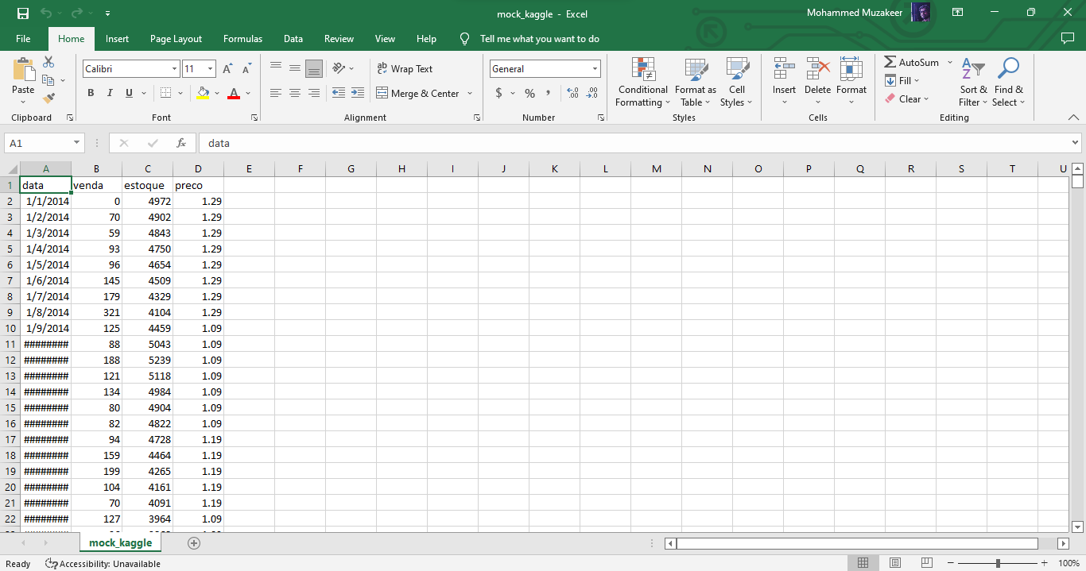

1. **Loading the dataset**

Tool Used – IBM Cognos Analytics

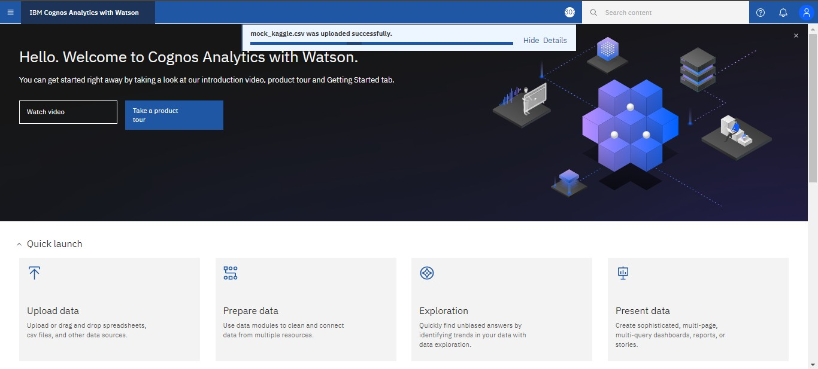

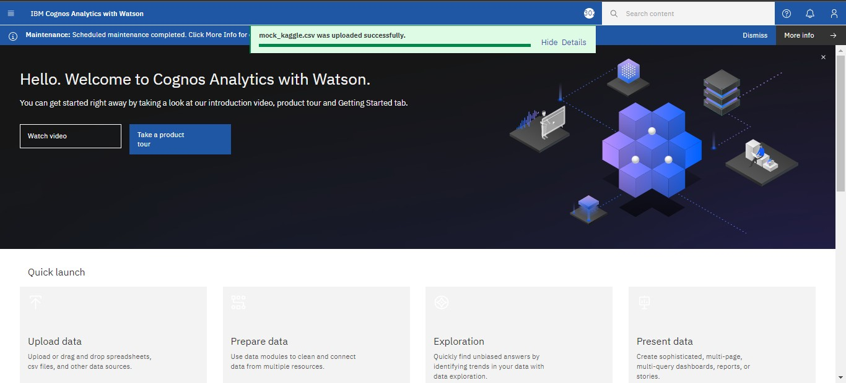

1. **Sales by Year:**

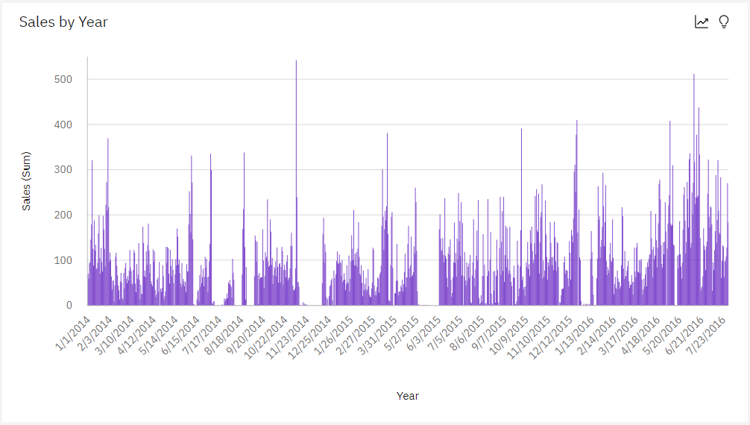

1. **Price by Year:**

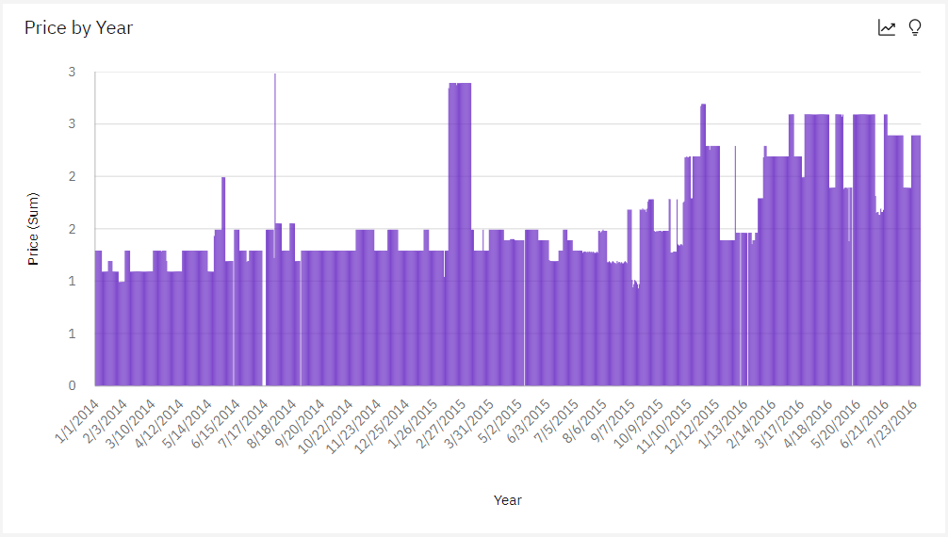

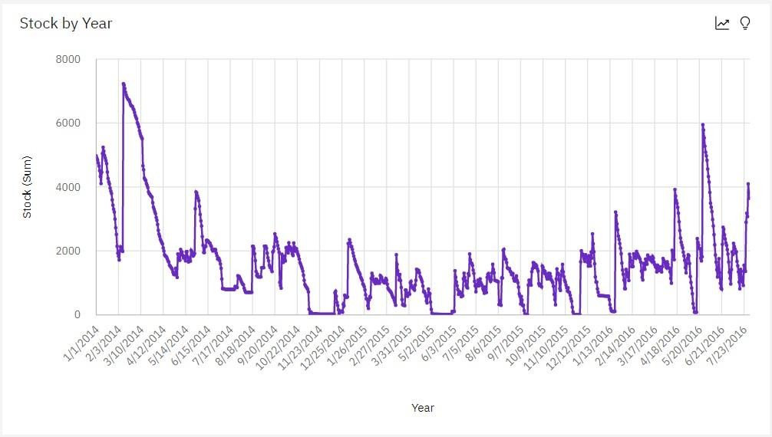

4. Sales by M_Data colored by M_Data:

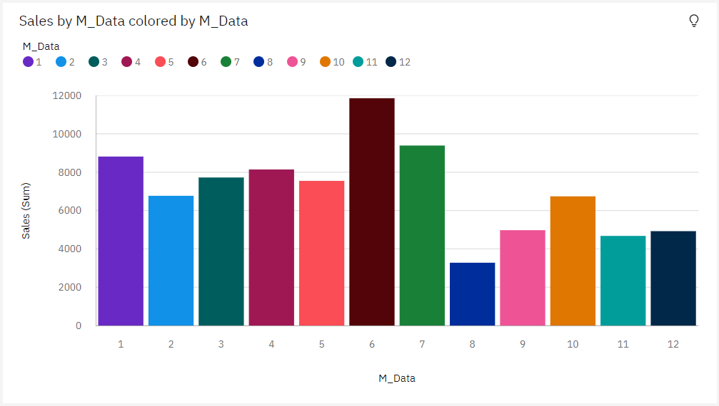

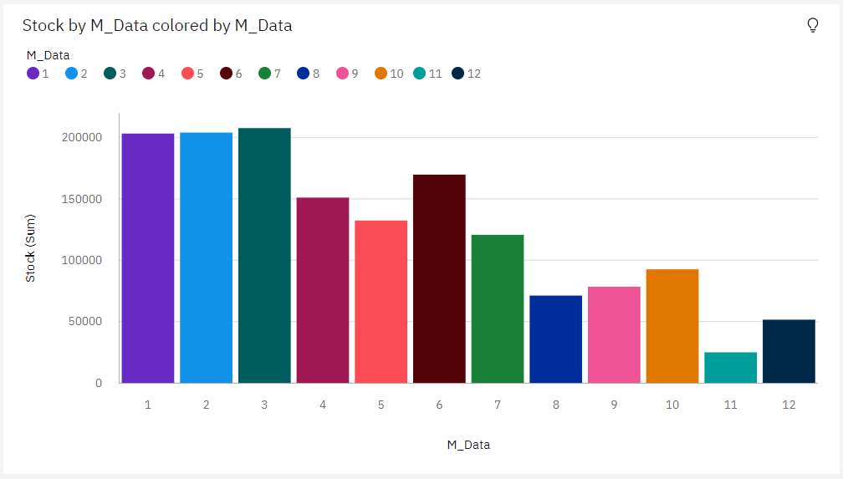

6. Price by M_Data colored by M_Data:

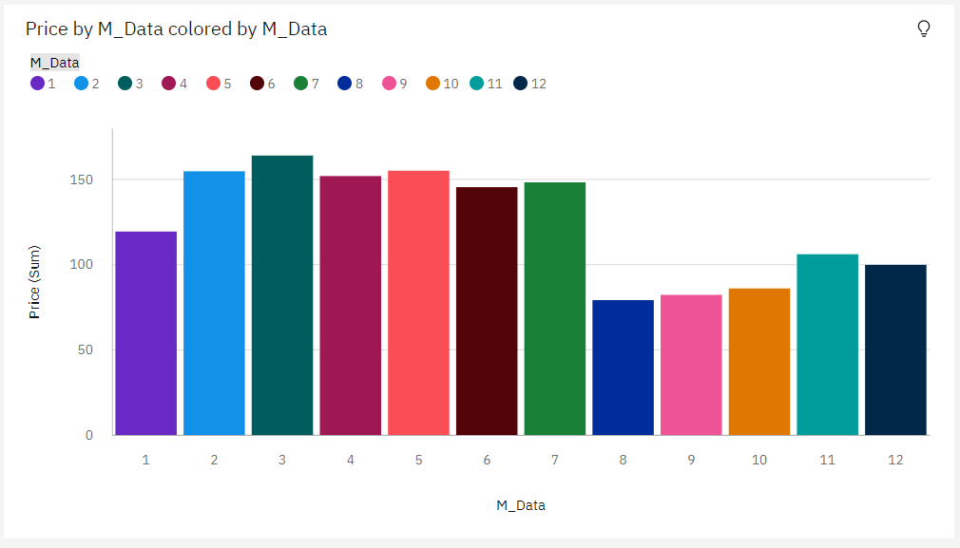

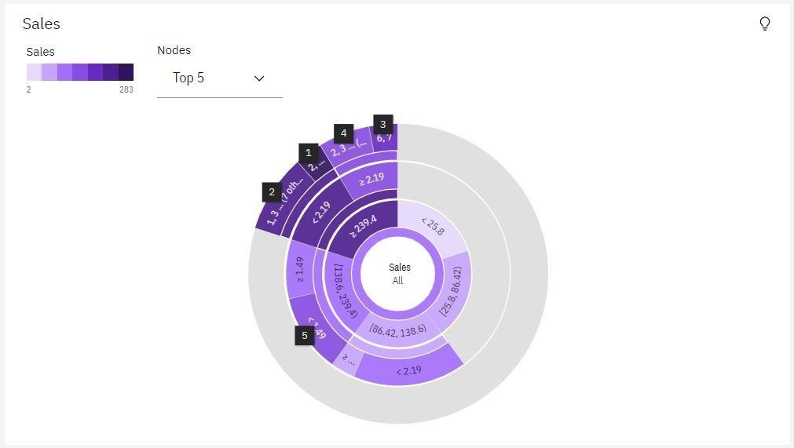

8. Stock Summary:

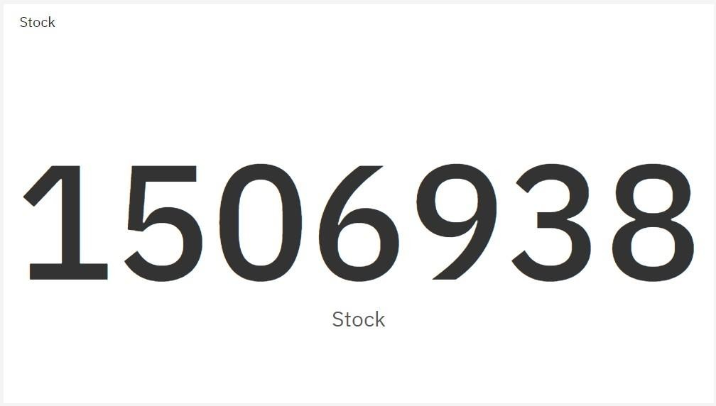

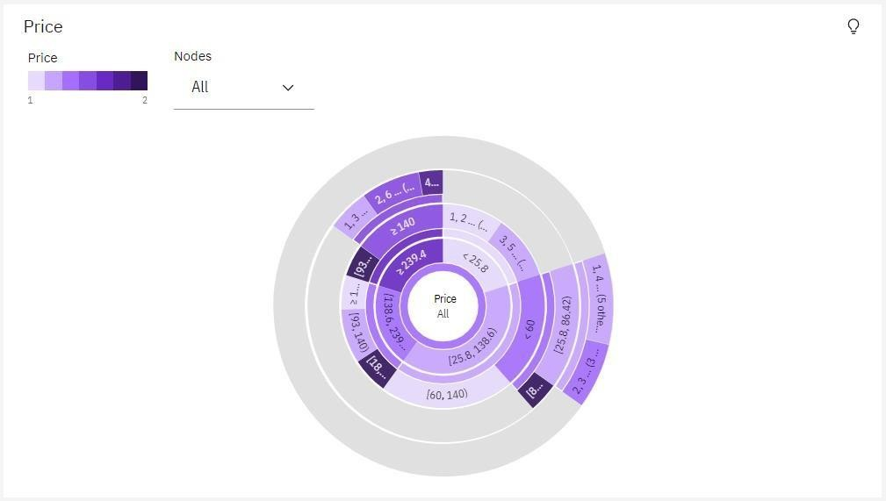

10. Year hierarchy colored by Year and sized by top 10 Sales:

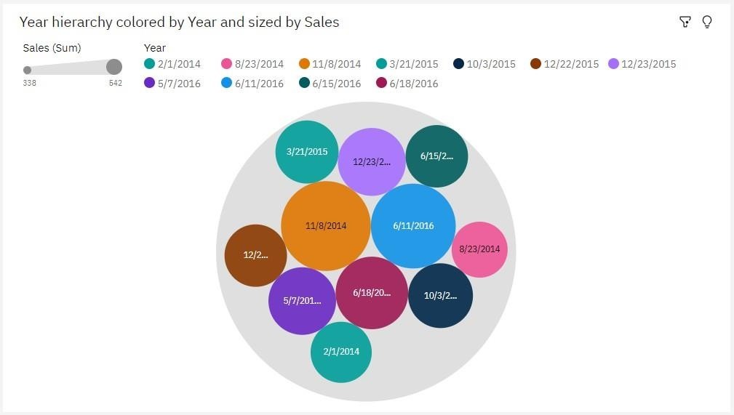

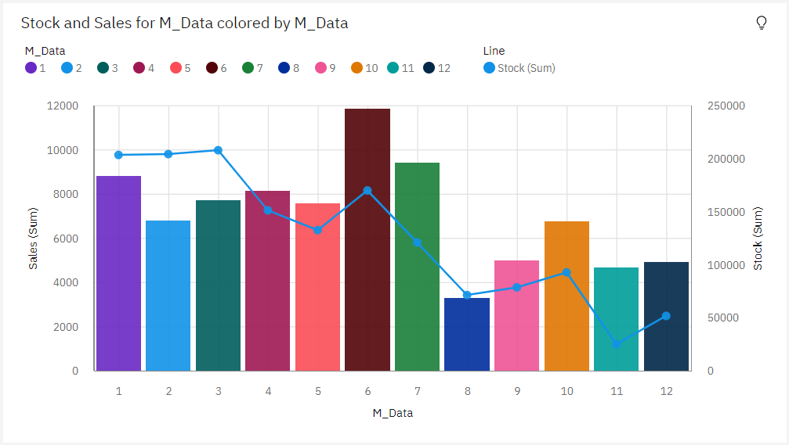

12. Top 10 Stock for Year hierarchy:

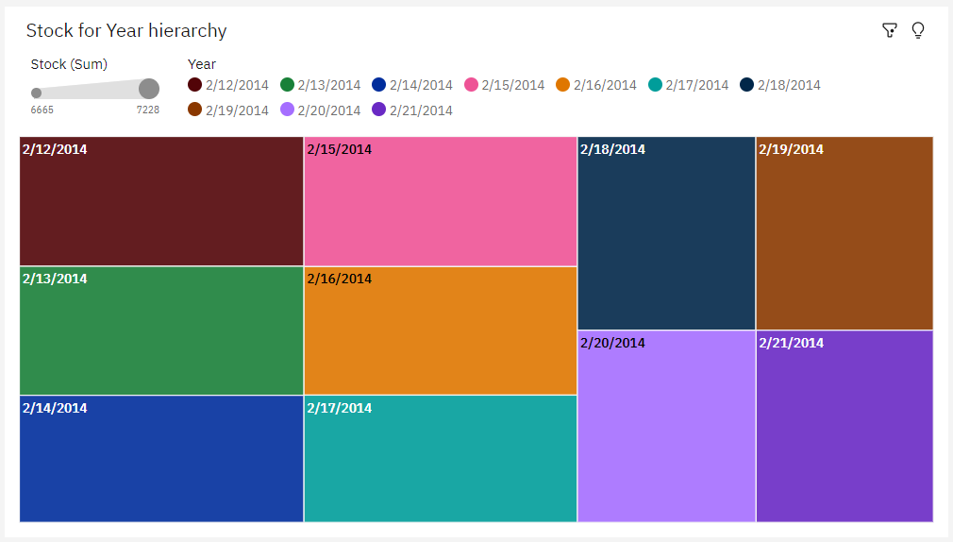

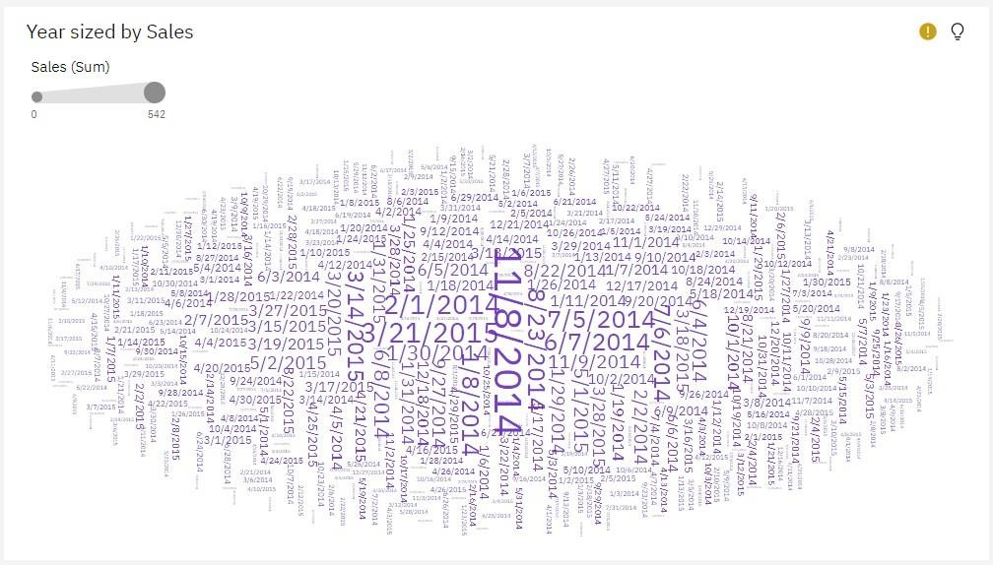

14. Revenue by Year:

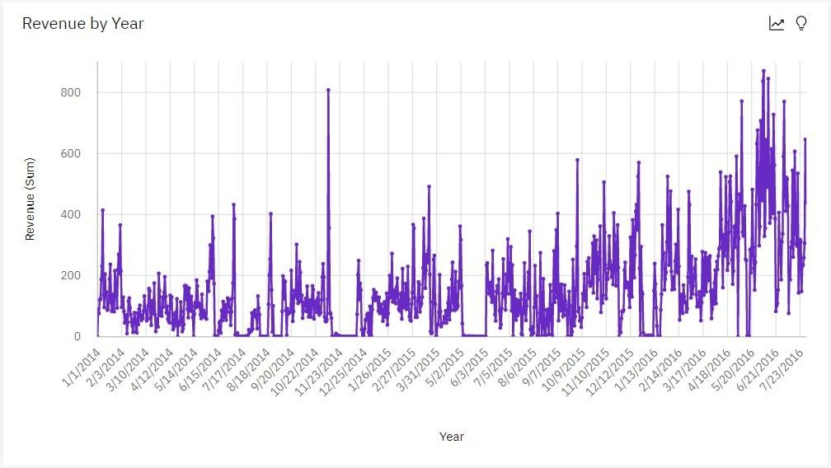

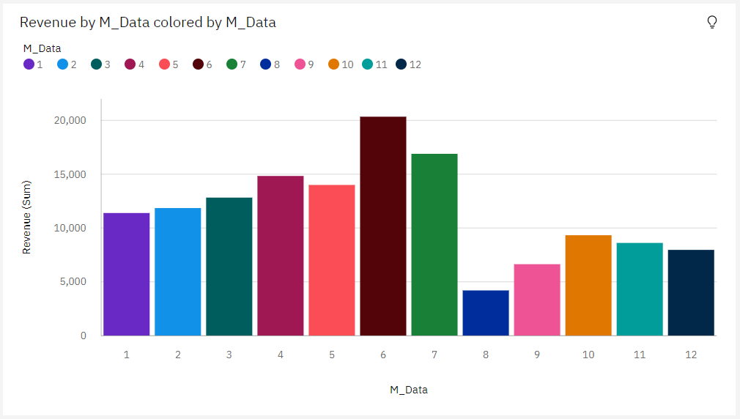

[https://us3.ca.analytics.ibm.com/bi/?perspective=dashboard&pathRef=.publ](https://us3.ca.analytics.ibm.com/bi/?perspective=dashboard&pathRef=.public_folders%2FVisualization%2FData%2BExploration&action=view&mode=dashboard) [ic_folders%2FVisualization%2FData%2BExploration&action=view&mode=das](https://us3.ca.analytics.ibm.com/bi/?perspective=dashboard&pathRef=.public_folders%2FVisualization%2FData%2BExploration&action=view&mode=dashboard) [hboard](https://us3.ca.analytics.ibm.com/bi/?perspective=dashboard&pathRef=.public_folders%2FVisualization%2FData%2BExploration&action=view&mode=dashboard)